Janet Marie (Reber) Worthington
April 4, 1937 – June 6, 2000

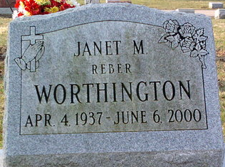
Photo by Thomas Liby

Janet Marie Worthington
in the Indiana, U.S., Death Certificates, 1899-2017
Name Janet Marie Worthington
[Janet Marie Reber]
Gender Female
Race White
Marital Status Divorced
Age 63
Birth Date 4 Apr 1937
Birth Place Craigville, In
Death Date 6 Jun 2000
Death Place Fort Wayne, Allen, Indiana, USA
Death Registration Date 1998
Father George Reber
Mother Hazel Shady
Informant Julie Prible; daughter; Bluffton, Indiana
Cremation June 9, 2000; Meeks Mortuary & Crematory; Muncie, Indiana

