Robert J. Worster
December 22, 1902 – April 28, 1968

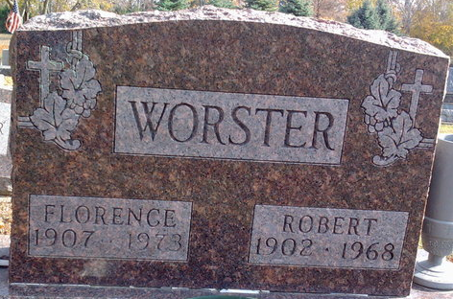
Photo by Thomas Liby

Robert J Worster
in the Indiana, U.S., Death Certificates, 1899-2017
Name Robert J Worster
Gender Male
Race White
Marital Status Married
Age 65
Birth Date 22 Dec 1902
Birth Place Indiana
Death Date 28 Apr 1968
Death Place Bluffton, Wells, Indiana, USA
Death Registration Date 1968
Father Robert Worster
Mother Nettie Rowe
Spouse Florence
Informant Wife; Bluffton, Indiana
Burial April 30, 1968; Elm Grove Cemetery; Bluffton, Indiana

