Robert B. Worster
May 29, 1873 – October 3, 1941

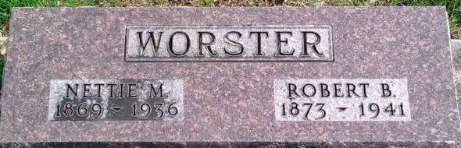
Photo by Thomas Liby

Robert B Worster
in the Indiana, U.S., Death Certificates, 1899-2017
Name Robert B Worster
Gender Male
Race White
Marital Status Widowed
Age 68
Birth Date 29 May 1873
Birth Place Liberty Center, Indiana
Death Date 3 Oct 1941
Death Place Bluffton, Wells, Indiana, USA
Death Registration Date 1941
Father James Worster
Mother Emeline Jamison
Spouse Nettie M Rowe
Informant Robert J. Worster; Bluffton, Indiana
Burial October 5, 1941; Elm Grove Cemetery; Bluffton, Indiana

