Nettie Maude (Rowe) Worster
December 24, 1869 – September 13, 1936

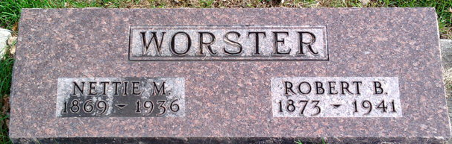
Photo by Thomas Liby

Nettie Maude Wooster
in the Indiana, U.S., Death Certificates, 1899-2017
Name Nettie Maude Wooster
[Nettie Maude Rowe]
Gender Female
Race White
Marital Status Married
Age 66
Birth Date 24 Dec 1869
Birth Place Beaver County, Pennsylvania
Death Date 13 Sep 1936
Death Place Bluffton, Wells, Indiana, USA
Death Registration Date 1936
Father Robert Rowe
Mother Margaret Lynch
Spouse Robert B Wooster
Informant Family
Burial September 16, 1936; Elm Grove Cemetery

