James Neil “Woose” Worster
August 12, 1931 – October 15, 1998

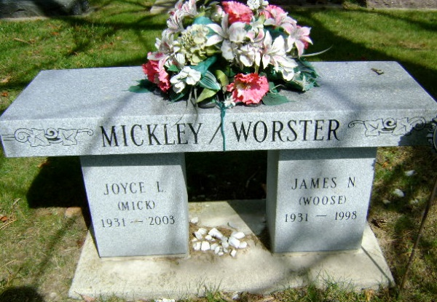
Photo by Bruce Sonner

James Neil Worster
in the Indiana, U.S., Death Certificates, 1899-2017
Name James Neil Worster
Gender Male
Race White
Marital Status Married
Age 67
Birth Date 12 Aug 1931
Birth Place Wells County, Indiana
Death Date 15 Oct 1998
Death Place Bluffton, Wells, Indiana, USA
Death Registration Date 1998
Father Robert Worster
Mother Florence Kimmel
Spouse Joyce Schmidt Mickley
Informant Joyce Worster; wife; Murray, Indiana
Cremation October 18, 1998; Meeks Crematory; Muncie, Indiana

