Howard B. Worster
November 22, 1907 – November 30, 1939

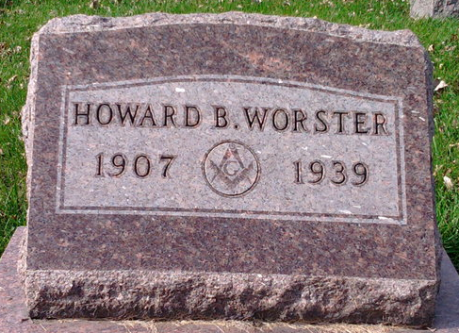
Photo by Thomas Liby

Howard B. Worster, 32, died today at the home here of a sister, Mrs. Joseph Roof, following an illness of heart trouble. He was employed at Monticello when he was stricken.
Surviving are the widow, Vivian; the father, Robert Worster, of Bluffton; a brother, Robert J. Worster, of Bluffton; and three sisters, Mrs. Roof and Mrs. Lawrence Markley, of Bluffton, and Mrs. Fred Tindall, of Davenport, Ia.
The body will be at the Jahn funeral home here until the hour of the funeral, at 1:30 o'clock Sunday afternoon at the First Evangelical and Reformed Church, in charge of the Rev. Matthew Worthman. Burial in Elm Grove Cemetery here.
The Muncie Star Press, Delaware County, Indiana
December 2, 1939

**
Indiana, U.S., Death Certificates, 1899-2017
Name Howard B. Worster
Gender Male
Race White
Marital Status Married
Age 32
Birth Date 22 Nov 1907
Birth Place Muncie, Indiana
Death Date 30 Nov 1939
Death Place Bluffton, Wells, Indiana, USA
Death Registration Date 1939
Father Robert B. Worster
Mother Nettie Rowe
Spouse Vivian Moon
Informant Mrs. Howard Worster; Monticello, Indiana
Burial December 3, 1939; Elm Grove Cemetery

