Florence (Kimmel) Worster
July 12, 1907 – June 7, 1973

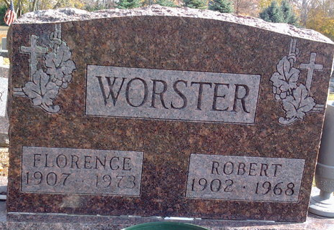
Photo by Thomas Liby

Florence Worster
in the Indiana, U.S., Death Certificates, 1899-2017
Name Florence Worster
[Florence Kimmel]
Gender Female
Race White
Marital Status Widowed
Age 65
Birth Date 12 Jul 1907
Birth Place Indiana
Death Date 7 Jun 1973
Death Place Bluffton, Wells, Indiana, USA
Death Registration Date 1973
Father Levi Kimmel
Mother Mary Tewell
Informant Richard Worster; son; Hartford City, Indiana
Burial June 9, 1973; Elm Grove Cemetery; Bluffton, Indiana

