Richard Albert Worden
August 10, 1910 – December 7, 2005

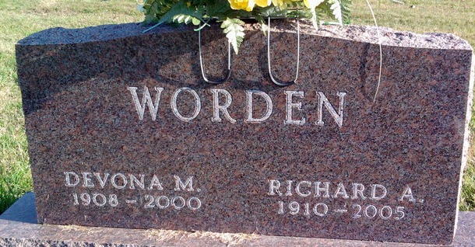
Photo by Thomas Liby

Richard Albert Worden, 95, died at 2 a.m. today, Dec. 7, 2005, at Christian Care Retirement Community. He was a long-time Bluffton resident. Mr. Worden managed the Craigville Elevator for 42 years along with his wife. He retired in 1972.
He was a member for many years of the Craigville United Methodist Church. In recent years, he became a member of Hope Missionary Church in Bluffton.
He was born Aug. 10, 1910, in Decatur to William F. and Charolotte (Lord) Worden. His marriage on Jan. 18, 1928, in Decatur was to Devona (Gerber) Worden, who preceded him in death on March 10, 2000. They were married 72 years.
Survivors include two sons, Robert Worden of Bluffton and William Worden of Fort Lauderdale, Fla.; 10 grandchildren; 25 great-grandchildren; and seven great-great-grandchildren.
He was preceded in death by five sisters and five brothers.
Services are at 11 a.m. Monday at Hope Missionary Church with Pastor Gary Aupperle officiating. Calling is from noon to 6 p.m. Sunday at Thoma/Rich, Hewitt & Chaney Funeral Home and one hour prior to services Monday at the church. Burial will be in Elm Grove Cemetery.
Preferred memorials are to Hope Missionary Church or Christian Care Retirement Community.

Bluffton News-Banner, Wells County, Indiana
December 8, 2005

