Devona M. (Gerber) Worden
December 16, 1908 – March 10, 2000

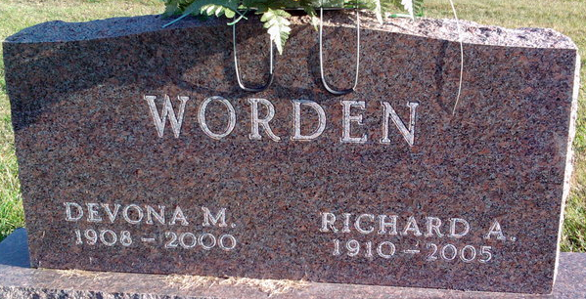
Photo by Thomas Liby

Devona M. Worden
in the Indiana, U.S., Death Certificates, 1899-2017
Name Devona M. Worden
[Devona M. Gerber]
Gender Female
Race White
Marital Status Married
Age 91
Birth Date 16 Dec 1908
Birth Place Adams County, Indiana
Death Date 10 Mar 2000
Death Place Bluffton, Wells, Indiana, USA
Death Registration Date 2000
Father William Gerber
Mother Ida Neuenschwander
Spouse Richard A. Worden
Informant Richard Worden; husband; Bluffton, Indiana
Burial March 13, 2000; Elm Grove Cemetery; Bluffton, Indiana

