Pearl Etta (Gerwig) Woods
November 4, 1893 – April 14, 1925

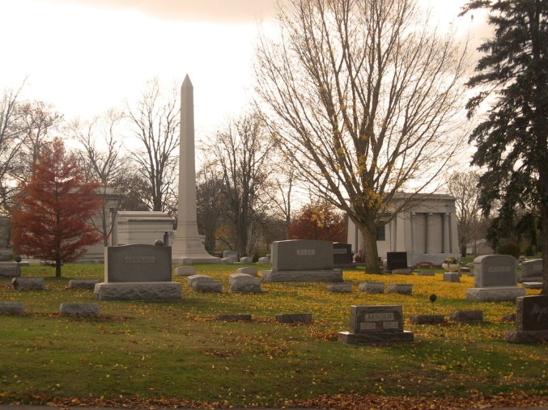
Photo by Tombstoner & Family

Bluffton, Indiana, April 15 - Mrs. Pearl Etta Woods, 31, wife of Loyal S. Woods died last night at the home of a sister, Mrs. Charles W. Smith, 820 South Johnson Street of complications following an illness of three months.
Funeral services will be held at the First Reformed Church at 3:30 o’clock Thursday afternoon and burial will be at Elm Grove.

The Star Press, Muncie, Indiana
April 16, 1925

**
Indiana, U.S., Death Certificates, 1899-2017
Name Pearl Etta Woods
[Pearl Etta Gerwig]
Gender Female
Race White
Marital Status Married
Age 31
Birth Date 4 Nov 1893
Birth Place Bluffton, Indiana
Death Date 14 Apr 1925
Death Place Bluffton, Wells, Indiana, USA
Death Registration Date 1925
Father Peter Gerwig
Mother Clara Lee
Spouse S.S. Woods
Informant Mrs. Chas. Smith; Bluffton, Indiana
Burial April 16, 1925; Elm Grove Cemetery

