Crystal G. (Foster) Woodbury
August 23, 1904 – December 10, 1997

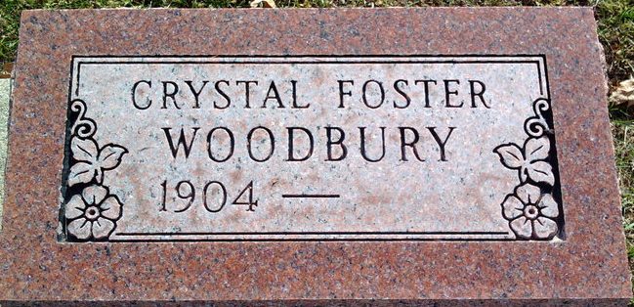
Photo by Thomas Liby

Crystal G Woodbury
in the Massachusetts, U.S., Death Index, 1970-2003
Name Crystal G Woodbury
Certificate 057974
Death Place Winchester
Death Date 10 Dec 1997
Birth Place Indiana
Birth Date 23 Aug 1904

**
Crystal G Foster from tree lehman family current
Birth 23 Aug 1904 Indiana, USA
Residence 1951 New Hampshire, USA
Death 10 Dec 1997 Winchester, Middlesex, Massachusetts, USA
Father John Irving Foster (1874-1919)
Mother Zettie Nancy (Rosella Boyer) Robinson (1881-1935)
Spouse Harold Whitcomb Woodbury (1908-1985)

