Helen Marie (Golden) Woodard
October 10, 1896 – April 22, 1970

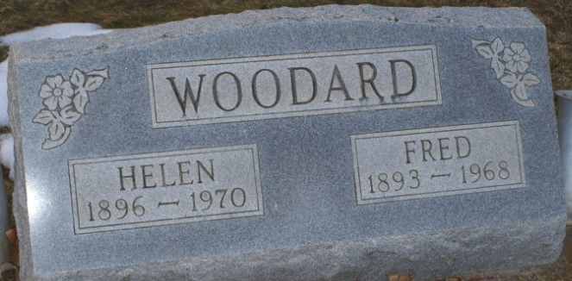
Photo by Bruce Sonner

Mrs. Helen M. Woodard, 73, of Bluffton, Route 4, widow of Fred E. Woodard, died today at Clinic Hospital. Born October 10, 1896 in Wells County, she was a daughter of William and Nora Steffy Golden. Her marriage to Fred E. Woodard, who died in 1968, took place in Bluffton August 11, 1913.
Surviving are two daughters, Mrs. Robert (Mildred) Meeks of Bluffton, Route 4 and Mrs. Duane (Madalyne) Squire of Battle Creek, Michigan; a son, Fred E. Woodard, Jr., of Ossian and three sisters, Mrs. Wilbur (Bessie) Colen and Mrs. Homer (Hazel) Smith, both of Bluffton, and Mrs. Ward (Bernice) Earle of Battle Creek.
Services will be held Friday at Thoma Funeral Home with burial in Elm Grove Cemetery.

Bluffton News-Banner, Wells County, Indiana
April 23, 1970
**

Indiana, U.S., Death Certificates, 1899-2017
Name Helen Marie Woodard
[Helen Marie Golden]
Gender Female
Race White
Marital Status Widowed
Age 73
Birth Date 10 Oct 1896
Birth Place Indiana
Death Date 22 Apr 1970
Death Place Bluffton, Wells, Indiana, USA
Father William Golden
Mother Nora Steffey
Informant Mrs. Robert Meeks; daughter; Bluffton, Indiana
Burial April 24, 1970; Elm Grove Cemetery; Bluffton, Indiana

