Fred Edward Woodward
June 17, 1893 – February 3, 1968

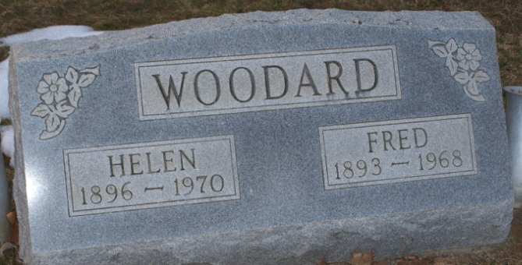
Photo by Bruce Sonner

Fred E Woodard
in the Indiana, U.S., Death Certificates, 1899-2017
Name Fred E Woodard
Gender Male
Race White
Marital Status Married
Age 74
Birth Date abt 1894
Birth Place Indiana
Death Date 3 Feb 1968
Death Place Bluffton, Wells, Indiana, USA
Death Registration Date 1968
Father John Woodard
Mother Arra Horrer
Spouse Helen M Golden
Informant Helen M. Woodard; wife; Bluffton, Indiana
Burial February 5, 1968; Elm Grove Cemetery; Bluffton, Indiana

**
Fred Edward Woodard from tree Shane Family Tree
Birth 17 Jun 1893 Fort Wayne, Allen, Indiana, USA
Marriage 9 Aug 1913 Wells, York, Maine, USA
Residence 1942 Indiana, USA
Death Feb 1968 Bluffton, Wells, Indiana, USA
Father John Wesley Woodard (Born 1873)
Mother Anna Elizabeth Horner (1878-1953)
Spouse Helen Marie Golden (1895-1970)

