Yale Robert Wood
June 17, 1965 – June 19, 1965

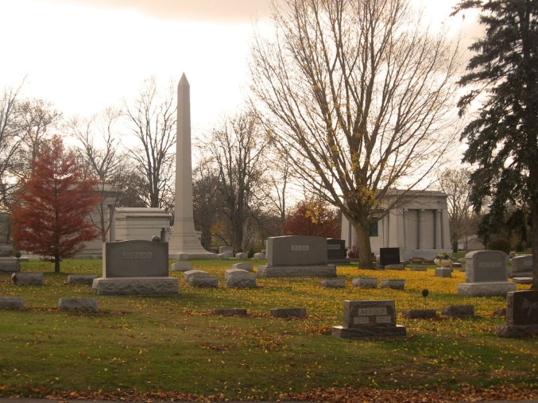
Photo by Tombstoner & Family

Yale Robert Wood
in the Indiana, U.S., Death Certificates, 1899-2017
Name Yale Robert Wood
Gender Male
Race White
Marital Status Never Married (Single)
Age 2 days
Birth Date 17 Jun 1965
Birth Place Indiana
Death Date 19 Jun 1965
Death Place Fort Wayne, Allen, Indiana, USA
Death Registration Date 1965
Father Robert Wood
Mother Eleanor Jean Morris
Informant Robert Wood; father; Bluffton, Indiana
Burial June 20, 1965; Elm Grove Cemetery; Bluffton, Indiana

