Robert H. Wood, Sr.
October 27, 1911 – December 12, 2006

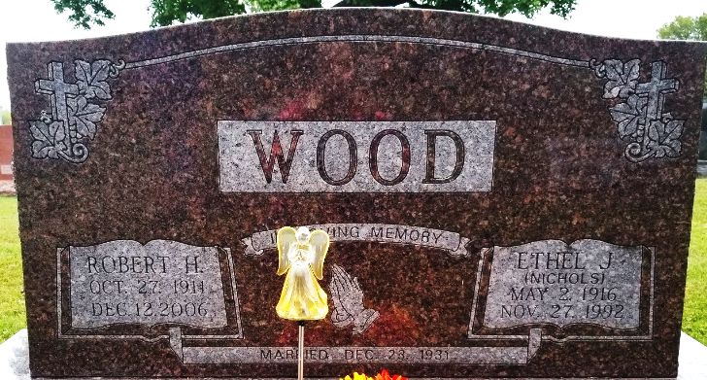
Photo by Bruce Sonner

A longtime Poneto resident, Robert H. Wood Sr., 95, died at 6:15 a.m. Tuesday, Dec. 12, 2006, at River Terrace Estates. Mr. Wood was a lifelong farmer and was a resident of Wells County since 1942. He resided on his farm in Poneto from 1959 to 2003, before moving to Bluffton. He moved to River Terrace in April 2006.
He attended First Church of the Nazarene in Bluffton and was a former member of the Poneto Lions Club and the Liberty Center Odd Fellows Lodge.
Born on Oct. 27, 1911, in Patrick County, Va., he was a son of Samuel and Alice (Bramer) Wood. His marriage on Dec. 23, 1931, in West Virginia was to Ethel Jane (Nicholas), who preceded him in death on Nov. 27, 1992.
Survivors include children Robert H. (Eleanor) Wood Jr. of Markle, Juanita (Kaye) Ivins of Bluffton, Willie L. Wood of LaCrescenta, Calif., and Judy (Robert) Haver of Rockford, Ohio; a brother, Herbert Wood of Meadows of Dan, Va.; two sisters, Anna Wood of Meadows of Dan and Genevieve Crews of Martinsville, Va.; 11 grandchildren; 27 great-grandchildren; and one great-great-grandchild. He was preceded in death by a sister; three brothers; and two grandchildren.
Calling is from 2 to 8 p.m. Sunday at Thoma/Rich, Hewitt & Chaney Funeral Home. Services are at 10 a.m. Monday at the funeral home with Pastor Larry Sheets officiating. Burial will be in Elm Grove Cemetery.
Preferred memorials are to the First Church of the Nazarene Building Fund or the American Cancer Society.

Thoma/Rich Funeral Home, Wells County, Indiana
December 13, 2006

