Robert H. “Woodie” Wood, Jr.
January 15, 1933 – June 19, 2024

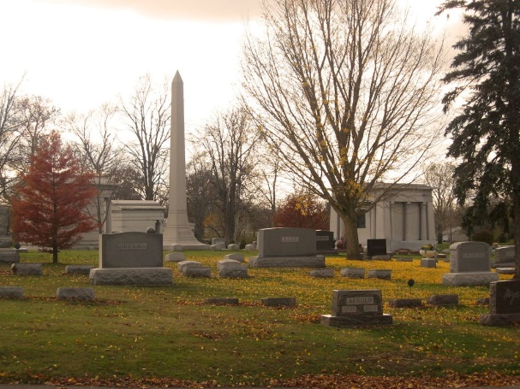
Photo by Tombstoner & Family

Robert H. (Woodie) Wood Jr. died at home June 19, 2024, surrounded by his loving family. Woodie was born January 15, 1933, in Hollywood, West Virginia to Robert and Ethel (Nichols) Wood. The family moved to Liberty Center, Indiana in 1941.
After graduating from Liberty Center High School in 1952, he worked for a short time at Franklin Electric in Bluffton and for Fruehauf Trailer Manufacturing in Fort Wayne, IN. On April 19, 1953, he married his high school sweetheart, Eleanor (Morris), at Liberty Center Baptist Church and was drafted into the US Army on April 25, 1953.
He served overseas, including six months in Germany and a year in France where his wife was able to join him and their first child was born. After being discharged in April 1955, Woodie worked for United Rural Electric Membership Corporation (Heartland) for 38 years, the last 22 years as CEO, retiring in January 1998. He was also elected to the board of directors of Federated Exchange in Kansas City, KS, where he served as secretary of the board for ten years. He was a member of the St. Mark's Lutheran Church in Uniondale for over 50 years.
Woodie is survived by his wife, Eleanor, of 71 years, three daughters: Lynnette (Steve) Rohring of Virginia Beach, Virginia; Cheryl (Tim) Hartigan of Bluffton, Indiana; and Carla (Kevin) Miller of Columbus, Ohio; in addition to eight grandchildren: Matthew (Sara) Rohring, Kelly (Dan) Benigno, Kerri (Geoff) Hubble, Kelsey (Zack) Hosford and Yale, Collin, Breckin and Sterling Miller. He is also survived by eight great-grandchildren, a sister, Juanita (Kaye) Ivins of Bluffton, and several nieces and nephews.
Woodie was preceded in death by an infant son, Yale Robert, his parents, Robert Sr. and Ethel Wood, a sister, Judy (Bob) Haver of Rockford, OH and a brother, Willie Lee (Sharon) Wood of Los Angeles, CA.
Woodie thoroughly loved his grandchildren, along with hunting, fishing, camping, his motor home and traveling. Following retirement Woodie and Ellie enjoyed a six-week trip to Alaska in their motor home. He loved the scenery and the salmon fishing and was fortunate enough to visit all fifty states in his lifetime. He and his family members enjoyed two wonderful trips to Europe. He was a constant, positive presence in his family's life as a devoted father and grandfather with a great sense of humor and determination, loving life to the fullest.
Visitation will be held Monday, June 24, from 3pm – 7pm at Thoma/Rich, Lemler Funeral Home in Bluffton. A memorial service will begin at 10:30am Tuesday, June 25, at St. Mark's Lutheran Church in Uniondale, IN, with one hour of calling prior to the service. Burial will follow at Elm Grove Cemetery in Bluffton with Military Honors by the American Legion Post #111 of Bluffton and United States Army Honor Guard.
In lieu of flowers/mementos, the family has directed gifts be sent to St. Mark's Lutheran Church.

Thoma/Rich Funeral Home, Wells County, Indiana
June 20, 2024

