George Seth Wood, Jr.
May 2, 1930 – October 24, 2015

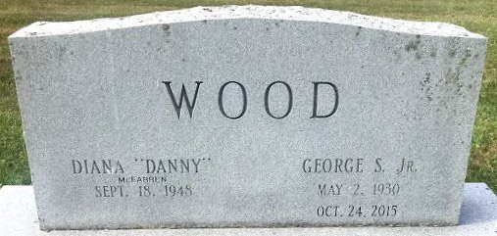
Photo by SMMR

George Seth Wood, Jr., 85, passed away in the early morning hours of Saturday, October 24, 2015.
This beloved man is survived by his wife, Danny (Diana McFarren) Wood; children, George Wood III, Nancy Wood, Jonathan (Beverly) Wood, Tim Wood, Todd (Brenda) Wood, Tony (Sherri) Wood, Kimberly Allen, and Chad (Peggy) Allen; grandchildren and great-grandchildren.
George was born on May 2, 1930, to George and Greeta (Sheehan) Wood in the beautiful town of St. Albans, Vermont. He and his two brothers, Jack and Lynn, and late sister, Donna Jean, spent great times on his grandparents' farm in Milton Boro. Spending summers at the farm, George shared hidden treasures of root beer that had been hidden in the ice houses through the winter. He thrived in high school, while playing high school baseball and trumpet in a professional adult dance band. Baseball and music were also pursued during 2 years at DePauw, where his love for writing blossomed.
As a sports editor and reporter at the St Albans Daily Messenger, he finished his BS at U of Vermont. He decided to forego careers in baseball and music, tried the newspaper and the family tire store, landed in education to incite conversation and challenge his students to clarify their thinking process. He began at Bellows Free Academy in St. Albans, got Masters and Doctoral degrees studying Community Education at Western Michigan, and found his place at Ball State University in Muncie, Indiana.
Words, music, and sports were woven through his life. George continued to write, to inspire his students to think, and to facilitate consensus in numerous communities and groups. In retirement, he enjoyed music, reading, bridge, his Chicago Cubs, and more writing. Throughout his life, he stimulated the individuality of his many family members and was able to get to know his terrific grandchildren. He will be remembered for many things, but especially how he challenged us toward richer meaning and thought.

Unknown source

