Ethel Jane (Nicholas) Wood
May 2, 1916 – November 27, 1992

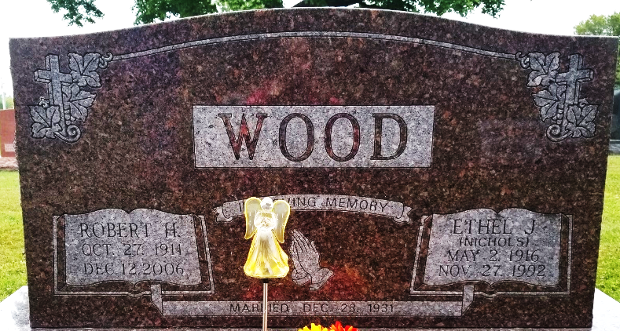
Photo by Bruce Sonner

Ethel Jane Wood
in the Indiana, U.S., Death Certificates, 1899-2017
Name Ethel Jane Wood
[Ethel Jane Nicholas]
Gender Female
Race White
Marital Status Married
Age 76
Birth Date 2 May 1916
Birth Place Hollywood West Virginia
Death Date 27 Nov 1992
Death Place Bluffton, Wells, Indiana, USA
Death Registration Date 1992
Father Caperton Nicholas
Mother Hettie Evans
Spouse Robert Wood
Informant Robert Wood; husband; Poneto, Indiana
Burial November 30, 1992; Elm Grove Cemetery; Bluffton, Indiana

