Eleanor J. (Morris) Wood
January 5, 1935 – March 20, 2025

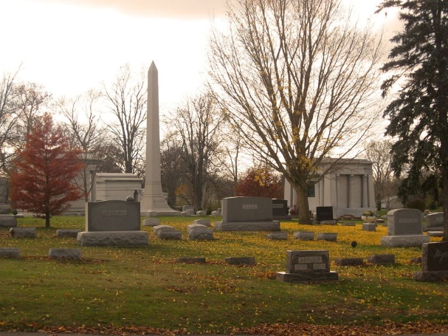
Photo by Tombstoner & Family

Eleanor J. Wood, 90, of Bluffton, passed away on Thursday morning, March 20, 2025, at Lutheran Hospital in Fort Wayne. She was born on January 5, 1935, in Tiskilwa, Illinois, to James and Nettie (Giltner) Morris.
After graduating from Liberty Center High School in 1952, she dedicated over 30 years to the Gallivan-Hamilton-Seese and Patterson law firm.
On April 19, 1953, Eleanor married her high school sweetheart, Robert H. “Woodie” Wood Jr., at Liberty Center Baptist Church before he was drafted into the Army. When Woodie was stationed in France, Eleanor joined him there, and together, they welcomed their first child. After his military service, the family returned to Wells County, where they built a life together. The couple celebrated 71 years of marriage before Woodie’s passing on June 19, 2024.
Eleanor was deeply involved in her community, serving on the Board of Directors for the Wells County Foundation. She was a devoted member of St. Mark’s Lutheran Church for over 50 years, actively contributing to various committees. An avid traveler, she visited all 50 states, including a memorable six-week tour of Alaska. However, her greatest joy was spending time with her family, especially her grandchildren.
She is survived by her three loving daughters: Lynnette (Steve) Rohring of Virginia Beach, Virginia; Cheryl (Tim) Hartigan of Bluffton, Indiana; and Carla (Kevin) Miller of New Albany, Ohio. She was a proud grandmother to eight grandchildren: Matthew (Sara) Rohring, Kelly (Dan) Benigno, Kerri (Geoff) Hubble, Kelsey (Zack) Hosford, and Yale, Collin, Breckin, and Sterling Miller, as well as a great-grandmother to eight. Eleanor is also survived by her three sisters: Mary Morris of Bluffton, Betty McComber of Tiskilwa, Illinois, and Anna Mae Schertz of Galesburg, Illinois, along with several nieces and nephews.
She was preceded in death by her husband, Robert “Woodie” Wood; an infant son, Yale Robert; her parents, James and Nettie Morris; and three brothers, Arley, Frank, and Jim Morris.
Eleanor will be remembered for her kindness, unwavering faith, and deep love for her family.
Visitation will be held from 3 P.M. to 7 P.M. on Friday, (APRIL 4, 2025) at the Thoma/Rich, Lemler Funeral Home in Bluffton and for one hour prior to the service at the church. Funeral services will begin at 10:30 A.M. on Saturday, (APRIL 5, 2025) at St. Mark’s Lutheran Church in Uniondale, with Rev. Terry Epling officiating. Burial will follow at Elm Grove Cemetery in Bluffton.
In lieu of flowers/mementos, the family has directed gifts be sent to St. Mark’s Lutheran Church.

Thoma/Rich Funeral Home, Wells County, Indiana
March 21, 2025

