Diana Kay (McFarren) Allen-Wood
September 18, 1948 -

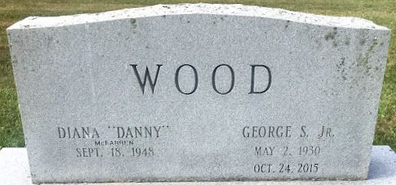
Photo by Tombstoner & Family

Diana K. McFarren
in the Indiana, U.S., Marriage Certificates, 1960-2012
Name Diana K. McFarren
Gender Female
Marriage Age 21
Birth Date abt 1948
Birth Place Indiana
Marriage Date 25 Oct 1969
Marriage Place Bluffton, Wells, Indiana, USA
Spouse Carl Dale Allen
Notes 2 N
Reference Number 1 Bx1447
Reference Number 2 Tr8452
Certificate Number 69-047468

**
Indiana, U.S., Marriage Certificates, 1960-2012
Name Diana Kay Allen
Gender Female
Marriage Age 34
Birth Date abt 1949
Birth Place Indiana
Marriage Date 6 May 1983
Marriage Place Bluffton, Wells, Indiana, USA
Spouse Gedale Seth Wood
Description Marion-Whitley
Notes 2 N
Reference Number 1 Bx1442
Reference Number 2 Tr8489
Certificate Number 83-014300
Box Number 2h

