Tracey LaVera (Hetrick) Wolf
October 4, 1898 – February 27, 1986

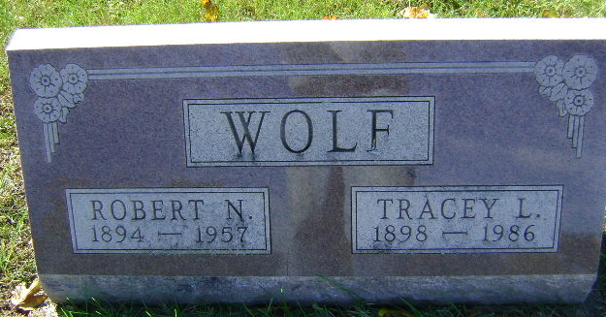
Photo by Bruce Sonner

Tracey Wolf
in the U.S., Social Security Death Index, 1935-2014
Name Tracey Wolf
Social Security Number xxx
Birth Date 4 Oct 1898
Issue year Before 1951
Issue State Indiana
Last Residence 45807, Lima, Allen, Ohio, USA
Death Date Feb 1986
**
Ohio, U.S., Death Records, 1908-1932, 1938-2022
Name Tracy L Wolf
Gender Female
Race White
Marital Status Widowed
Death Age 87
Birth Date Abt 1899
Birth Place Indiana, USA
Residence Place Allen, Ohio, USA
Death Date 27 Feb 1986
Death Place Lima, Allen, Ohio, USA
Industry Homemaker, Student, Unemployed Volunteer
Occupation Homemaker
Certificate Number 007084
Inquest Hospital St Ritas Medical Center
Inquest Questions Certifier: Physician;
**
Tracey LaVera Hetrick from tree Abbott/Denham Family Tree
Birth 4 Oct 1898 Wells, Indiana, USA
Marriage 4 Dec 1918 Boston, Suffolk, Massachusetts, USA
Residence 1 Apr 1940 Wells, Indiana, USA
Death 27 Feb 1986 Lima, Allen, Ohio, USA
Father Amos Harlow Hetrick (1875-1948)
Mother Rosa Aretta Abbott (1878-1967)
Spouse Robert Nyle Wolf (1894-1957)

