Robert Nyle Wolf
June 4, 1894 – November 18, 1957

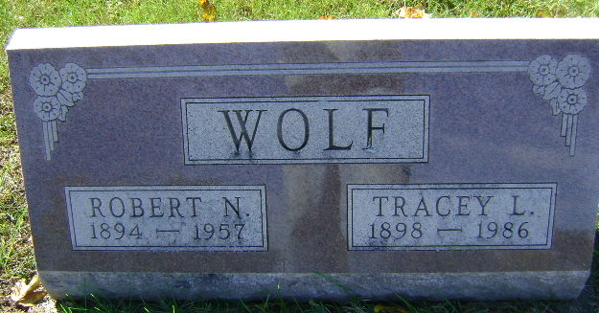
Photo by Bruce Sonner

Robert Nyle Wolf
in the Indiana, U.S., Death Certificates, 1899-2017
Name Robert Nyle Wolf
Gender Male
Race White
Marital Status Married
Age 63
Birth Date 4 Jun 1894
Birth Place Indiana
Death Date 18 Nov 1957
Death Place Bluffton, Wells, Indiana, USA
Death Registration Date 1957
Father Charles Wolf
Mother Rose Trullender
Informant Mrs. R. N. Wolf; wife; Craigville, Indiana
Burial November 21, 1957; Elm Grove Cemetery; Bluffton, Indiana

