Paul Wolf
November 6, 1930 – November 9, 1930

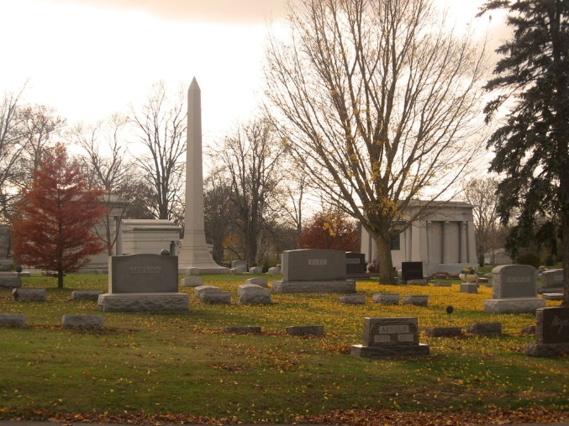
Photo by Tombstoner & Family

Paul Wolf
in the Indiana, U.S., Birth Certificates, 1907-1944
(Original illegible)

Name Paul Wolf
Gender Male
Birth Date 6 Nov 1930
Birth Place Lancaster, Wells, Indiana, USA
Father Dewitt T. Wolf; age 33
Mother Esther Arnold; age 34; 7th child, all living
Certificate Number 54309
Roll number 40474_356519
Volume Range 105 - 110

**
Indiana, U.S., Death Certificates, 1899-2017
Name Robert Wolf
Gender Male
Race White
Marital Status Single
Age 0
Birth Date 6 Nov 1930
Birth Place Lancaster Tp. Wells Co, Indiana
Death Date 9 Nov 1930
Death Place Lancaster, Wells, Indiana, USA
Death Registration Date 1930
Father Dewitt Wolf
Mother Esther Arnold
Informant Dewitt Wolf; Bluffton, Indiana
Burial November 10, 1930; Elm Grove Cemetery

