Cora L. (Henschen) Wolf
March 8, 1896 – July 25, 1972

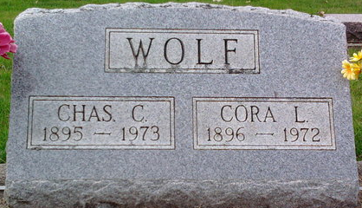
Photo by Thomas Liby

Mrs. Cora L. Wolf, 76, of Bluffton, Route 2, died today at Wells Community Hospital. A daughter of Jacob E. and Mary Spangler Henschen, Mrs. Wolf was born March 8, 1896 in Adams County. Her marriage to Mr. Wolf, who survives, took place February 25, 1917 at Craigville.
A resident of Wells County most of her life, she was a member of the Blanche Chapel United Methodist Church.
Surviving is a son, Gene E. of Fort Wayne; four daughter, Mrs. Claude (Wilma) Dolby of Bluffton, Mrs. Joe (Helen) Campbell of Ashland, Ohio, Mrs. Thomas (Edna) Wildey of North Webster, and Mrs. Eugene (Harriet) Gerard of Poneto, Route 1. Also surviving is a brother, Noah Henschen of Bedford; two sisters, Mrs. Lydia Bracht of Bluffton and Mrs. Ida Overholser of Bradford, Ohio; 14 grandchildren and eight great-grandchildren.
Thoma Funeral Home is in charge where services will be held Thursday with burial in Elm Grove Cemetery.

Wells County, Indiana Obituaries
1969 - 1974

