Charles C. Wolf
December 28, 1895 – August 27, 1973

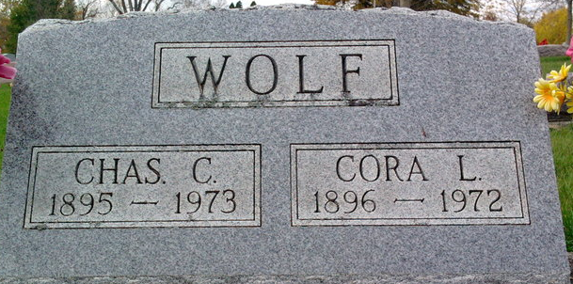
Photo by Thomas Liby

Charles C Wolf
in the Indiana, U.S., Death Certificates, 1899-2017
Name Charles C Wolf
Gender Male
Race Caucasian (White)
Marital Status Widowed
Age 77
Birth Date 28 Dec 1895
Birth Place Indiana
Death Date 27 Aug 1973
Death Place Bluffton, Wells, Indiana, USA
Death Registration Date 1973
Father Samuel Wolf
Mother Harriett Essex
Informant None named
Burial August 30, 1973; Elm Grove Cemetery; Bluffton, Indiana

