Josephine B. (Beeler) Witzeman
January 6, 1906 – May 14, 1993

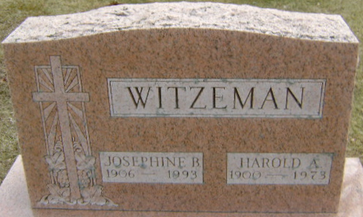
Photo by Bruce Sonner

Josephine B Witzeman
in the Indiana, U.S., Death Certificates, 1899-2017
Name Josephine B Witzeman
[Josephine B Beeler]
Gender Female
Race White
Marital Status Widowed
Age 87
Birth Date 6 Jan 1906
Birth Place Wells County, Indiana
Death Date 14 May 1993
Death Place Bluffton, Wells, Indiana, USA
Death Registration Date 1993
Father Manasses Beeler
Mother Elizabeth Arnold
Informant Dorothy Springer; daughter; Bluffton, Indiana
Burial May 16, 1993; Elm Grove Cemetery; Bluffton, Indiana

