Harold A. Witzeman
March 14, 1900 – August 21, 1973

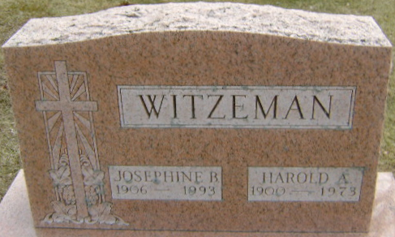
Photo by Bruce Sonner

Harold A Witzeman
in the Indiana, U.S., Death Certificates, 1899-2017
Name Harold A Witzeman
Gender Male
Marital Status Married
Age 73
Birth Date 14 Mar 1900
Birth Place Indiana
Death Date 21 Aug 1973
Death Place Bluffton, Wells, Indiana, USA
Death Registration Date 1973
Father Adolph C Witzeman
Mother Emily Meyer
Spouse Josephine
Informant Hospital chart
Burial August 24, 1973; Elm Grove Cemetery; Bluffton, Indiana

