Emilie (Meyer) Witzeman
September 21, 1877 – July 13, 1962

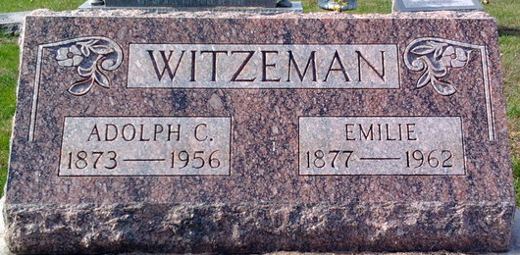
Photo by Thomas Liby

Emilie Witzeman
in the Indiana, U.S., Death Certificates, 1899-2017
Name Emilie Witzeman
[Emilie Meyer]
Gender Female
Race White
Marital Status Widowed
Age 84
Birth Date 21 Sep 1877
Birth Place Ohio
Death Date 13 Jul 1962
Death Place Bluffton, Wells, Indiana, USA
Death Registration Date 1962
Father Carl Meyer
Mother Anna Feller
Informant Howard A. Witzeman; son; Bluffton, Indiana
Burial July 16, 1962; Elm Grove Cemetery; Bluffton, Indiana

