Adolph Christian Witzeman
December 19, 1873 – July 7, 1956

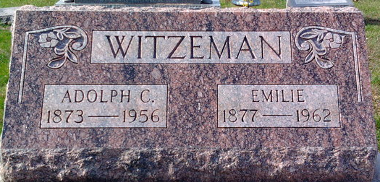
Photo by Thomas Liby

Adolph Christian Witzeman from tree springer-wyatt
Birth 19 Dec 1873 Vera Cruz, Wells, Indiana, USA
Marriage 11 Oct 1894 Adams, Berkshire, Massachusetts, USA
Residence 1 Apr 1940 Bluffton, Wells, Indiana, USA
Death 7 Jul 1956 Bluffton, Wells, Indiana, USA
Father Mathias Witzeman (1848-1918)
Mother Christena Witzeman (1849-1923)
Spouse Emilie Meyer (1878-1962)

