Lulu M. (Shively) Wittwer-Jackson
July 23, 1896 – June 15, 1978

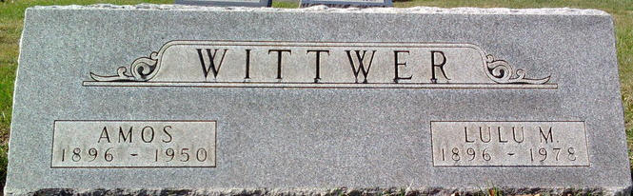
Photo by Thomas Liby

Lulu M Jackson
in the Indiana, U.S., Death Certificates, 1899-2017
Name Lulu M Jackson
[Lulu M Shively]
Gender Female
Race White
Marital Status Widowed
Age 81
Birth Date 23 Jul 1896
Birth Place Indiana
Death Date 15 Jun 1978
Death Place Bluffton, Wells, Indiana, USA
Death Registration Date 1978
Father David Shively
Mother Mary Horner
Informant Mr. Richard Jackson; Decatur, Indiana
Burial June 17, 1978; Elm Grove Cemetery; Bluffton, Indiana

