Lee Wittwer
January 13, 1904 – February 5, 1990

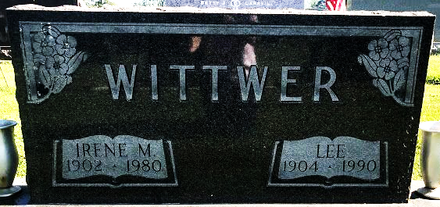
Photo by SMMR

Indiana, U.S., Death Certificates, 1899-2017

Name Lee Wittwer
Gender Male
Race White
Age 86
Marital Status Married
Birth Date 13 Jan 1904
Birth Place Woodburn, Indiana
Death Date 5 Feb 1990
Death Place Bluffton, Wells, Indiana, USA
Death Registration Date 1990
Father Christian Wittwer
Mother Josephine Baumgartner
Spouse Oma Grennawalt
Informant Larry L. Wittwer, Bluffton, IN
Burial Elm Grove February 8, 1990

