Larry Lee Wittwer
January 20, 1934 – December 8, 2014

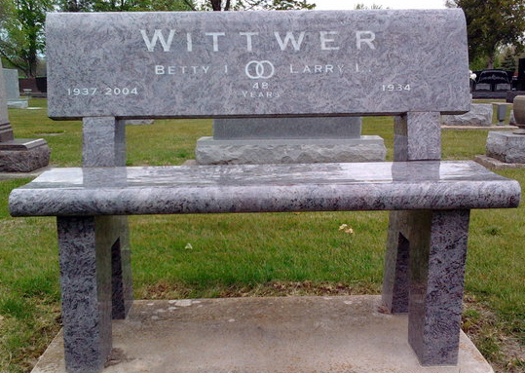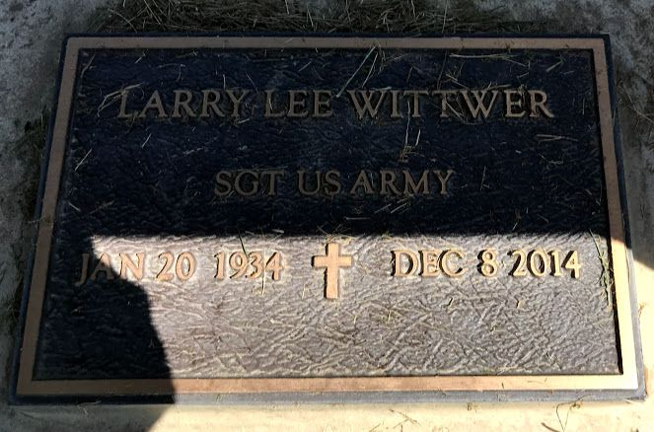
Photo by Thomas Liby & SMMR

Larry Wittwer, of Angola, Indiana and longtime resident and business owner from Bluffton, Indiana, passed away Monday, December 8, near Walnut Creek, California, while on vacation visiting his son, Jerry. Larry, 80, died from complications following emergency surgery the prior week.
Larry was a kind and gentle family man, generous friend, successful businessman, accomplished craftsman, water sports enthusiast and avid collector. He was equally at home and happy on a windsurf board, behind the wheel of a mint condition restored Mustang, playing a round of dominos or at his workbench.
Larry was born in Bluffton on January 20, 1934 to Lee and Irene (Tonner) Wittwer. He was married to Betty (Steele) Wittwer for 48 years until her death in 2004. A 1952 graduate of Lancaster High School, Larry received a radio and television certification from DeVry Technical Institute. In 1956, he served two years in the US Army’s Signal Corps based in Fort Huachuca, Arizona. From 1964 to 1999, he owned and operated Wittwer TV Sales & Service in Bluffton. Larry was remarried in 2011 to Mary Westfall.
Survivors include wife, Mary Westfall of Angola, IN, daughter and son-in law Suzi and Greg Hahn of White Plains, MD; son and daughter-in-law Jerry Wittwer and Didi D’Errico of Walnut Creek, CA; two grandchildren, Nicholas and Olivia Wittwer; and a sister Karen Griffin, of Lewis Center, OH. He will be missed by a wide circle of friends and extended family including Mary’s children, Chandra Westfall, Dennis and Bernadette Westfall and John and Tricia Westfall, and seven grandchildren in Indiana and Toronto.
Burial will be in Elm Grove Cemetery.

Thoma/Rich Funeral Home, Wells County, Indiana
December 9, 2014

