Irene M. (Tonner) Wittwer
August 9, 1902 – February 9, 1980

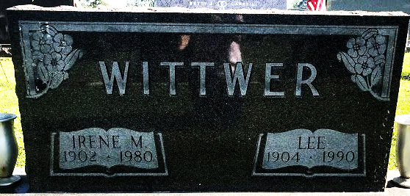
Photo by SMMR

Irene Wittwer
in the Indiana, U.S., Death Certificates, 1899-2017
Name Irene Wittwer
[Irene Tonner]
Gender Female
Race White
Marital Status Married
Age 77
Birth Date 9 Aug 1902
Birth Place Indiana
Death Date 9 Feb 1980
Death Place Bluffton, Wells, Indiana, USA
Death Registration Date 1980
Father John Tonner
Mother Mary Lobsiger
Spouse Lee Wittwer
Informant Lee Wittwer; Bluffton, Indiana
Burial February 11, 1980; Elm Grove Cemetery; Bluffton, Indiana

