Betty J. (Steele) Wittwer
October 8, 1937 – November 3, 2004

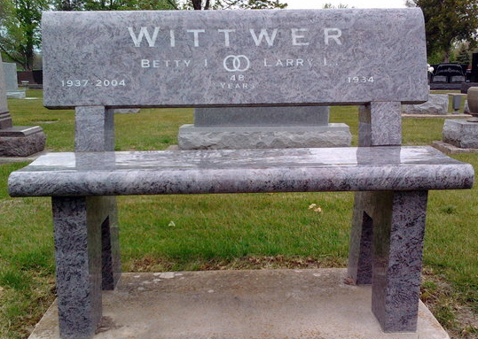
Photo by Thomas Liby

Betty J. Wittwer, 67, of Bluffton, died at 9:03 a.m. Wednesday, Nov. 3 at Lutheran Hospital in Fort Wayne. Death was attributed to a cerebral hemorrhage from a hematoma she suffered Oct. 15.
Born in Bluffton Oct. 8, 1937 to Chalmer and Margaret McCormick Steele, she married Larry L. Wittwer July 29, 1956, at the First United Church of Christ in Bluffton.
She was a 1955 graduate of Bluffton High School. She attended Contromiter School and was employed by General Electric for several years. From 1964 to 1999, she and her husband owned and operated Wittwer TV in Bluffton. She was a member of the First United Church of Christ.
Survivors include a son, Jerry Wittwer, of Walnut Creek, Calif.; a daughter Mrs. Greg (Suzi) Hahn of White Plains, Md.; a twin brother, Bob Steele of Ossian and another brother, Vincent Chalmer Steele of Fort Wayne; and two grandchildren. She was preceded in death by her sister, Clara Lou Mygrant.
Services at Thoma/Rich, Hewitt & Chaney Funeral Home will be held at 1:30 p.m. Sunday under the direction of Rev. Neil Wilson. Burial will follow at Elm Grove Cemetery. Calling hours at the funeral home will be from noon to 4 p.m. and 6 to 8 p.m. Saturday and one hour prior to services Sunday.
Memorials may be made to the Juvenile Diabetes Association or to the donor’s choice.
Bluffton News Banner, Wells County, Indiana
November 4, 2004

