Amos Wittwer
March 4, 1896 – February 15, 1950

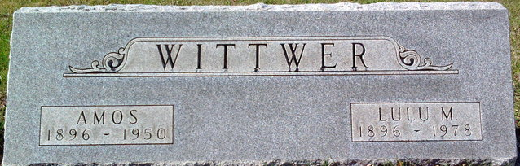
Photo by Thomas Liby

Handwritten date: Wednesday, February 15, 1950

AMOS WITTWER DIES EARLY TODAY
FORMER LOCAL RESIDENT DIES AT BLUFFTON; RITES ON FRIDAY

Amos “Chick” Wittwer, 54, of 1019 South Main Street, in Bluffton, a native of this community, died at 3:45 a.m. this morning at a Bluffton hospital from a heart attack he suffered Monday. He had suffered with diabetes for a long time but was able to be at work until Monday when he suffered the heart attack. He was employed at the Fort Wayne plant of the General Electric Company.
Wittwer was born in this community and was the son of Chris and Josephine Baumgartner Wittwer, both deceased.
Surviving are the widow and the following brothers and sisters: Ed, Jesse, and Edna, all of Berne; Mrs. John Stucky, Geneva R.R.; Lee, Adolph and Albert, all of Bluffton and Otto and Noah, both of Fort Wayne. A sister, Mrs. Albert Augsburger, preceded in death.
Friends may call at the home in Bluffton after 5:00 p.m. today. The funeral will be held Friday afternoon but definite arrangements were not available at press time today.

Adams County Historical Museum, Adams County, Indiana
October 1949 – February 1950 Scrapbook

**
Indiana, U.S., Death Certificates, 1899-2017
Name Amos Wittwer
Gender Male
Race White
Age 53
Marital Status Married
Military WW I
Birth Date 4 Mar 1896
Birth Place Adams County, Indiana
Death Date 15 Feb 1950
Death Place Bluffton, Wells, Indiana, USA
Death Registration Date 1950
Father Chris Wittwer
Mother Josephine Baumgartner
Informant Mrs. Amos Wittwer, Bluffton, IN
Burial Elm Grove Cemetery, Bluffton 2/17/1950

