Zola M. (Stewart) Wisner
December 17, 1893 – January 11, 1984

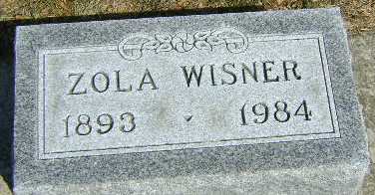
Photo by Bruce Sonner

ZOLA M. WISNER, 90, DIES; RITES WILL BE SATURDAY
Last of her family, which included two brothers, Mrs. Zola M. Wisner, 90, died at 9:45 p.m. Wednesday at the Clinic Hospital, where she had been a patient six hours. She had been ill since September.
A native and lifelong resident of Wells County, she lived at 5531E 300N, Craigville. She was born Dec. 17, 1893, a daughter of Robert and Emma Shady Stewart. Her marriage at her home Jan. 18, 1912, was to Alfred Wisner, whose death occurred in 1964.
Mrs. Wisner was a member of the First United Church of Christ.
Surviving is one daughter, Mrs. Charles Louise Hedges of Bluffton Route 5, four grandchildren and five great-grandchildren.
Services will be conducted by Rev. Calvin Ley and Rev. Randy Rossman at 1:30 p.m. Saturday at the Goodwin Memorial Chapel. Burial will be in Elm Grove Cemetery. Calling at the funeral home will begin at 7 p.m. today and after 2 p.m. Friday and until time for services Saturday.
Preferred are memorials to the Wells County Cancer Fund.

Bluffton News-Banner, Wells County, Indiana
Thursday, January 12, 1984

