William Wisner
November 9, 1808 – October 30, 1888

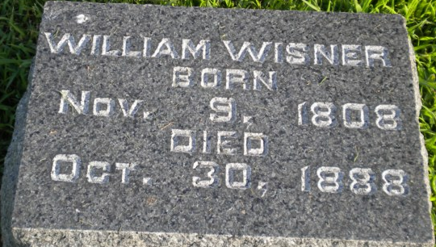
Photo by PLGS

William Wisner from tree 2nd Wisner Family Tree
Birth 9 Nov 1808 Lycoming, Pennsylvania, USA
Marriage 27 Sep 1864 Wells, Indiana, USA
Residence 1880 Wells, Indiana, USA
Death 30 Oct 1888 Wells, Indiana, USA
Father Benoni Wisner (1764-1828)
Mother Agnes Hooper (1770-1835)
Spouse Mary Plummer (1810-1863)
Spouse Mary Nash (1829-1893)

