Sophia (Kunkel) Wisner
March 16, 1840 – February 15, 1879

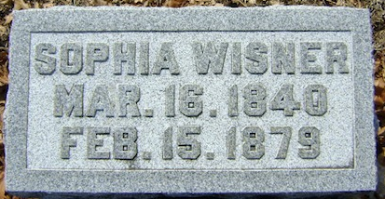
Photo by Bruce Sonner

Sophia Kunkel from tree The Family History of Robb Ray Reed
Birth 16 Mar 1840 Ohio, USA
Marriage 10 Oct 1867 Wells, Indiana, USA
Residence 21 Jun 1870 Wells, Indiana, USA
Death 15 Feb 1879
Father Michael Kunkel (1816-1886)
Mother Julia Mason (1816-1849)
Spouse John Wisner (1834-1917)

