Silas Wisner
October 30, 1854 – June 23, 1931

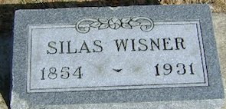
Photo by Bruce Sonner

Silas Wisner
in the Indiana, U.S., Death Certificates, 1899-2017
Name Silas Wisner
Gender Male
Race White
Marital Status Married
Age 76
Birth Date 30 Oct 1854
Birth Place Wells County, Indiana
Death Date 23 Jun 1931
Death Place Lancaster, Wells, Indiana, USA
Death Registration Date 1931
Father William Wisner
Mother Mary Plummer
Spouse Jennie M. Masterson
Informant Alfred Wisner; Bluffton, Indiana
Burial June 25, 1931; Elm Grove Cemetery

