Sharp Karas Wisner
April 1, 1879 – May 26, 1916

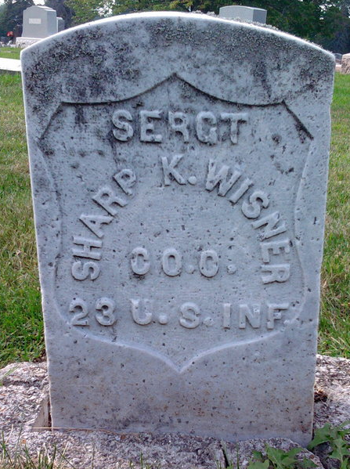
Photo by Thomas Liby

Sharp Karas Wisner
in the Cook County, Illinois, U.S., Deaths Index, 1878-1922
Name Sharp Karas Wisner
Birth Date 1 Apr 1880
Birth Place Indiana
Death Date 26 May 1916
Death Place Chicago, Cook, Illinois
Burial Date 27 May 1916
Burial Place Bluffton, Indiana
Death Age 36
Occupation Bookkeeper
Race White
Marital Status Divorced
Gender Male
Residence Indiana
Father Name Horace
Father Birth Place Bluffton, Indiana
Mother Name Karnes
Mother Birth Place Bluffton Indiana
FHL Film Number 1276300
**
Indiana, U.S., Marriages, 1810-2001
Name Sharpe K Wisner
Gender Male
Race White
Age 26
Event Type Marriage Registration (Marriage)
Birth Date 1 Apr 1880
Birth Place Wells, Indiana
Marriage Date 10 Jul 1906
Marriage Place Indiana, United States
Residence Place Bluffton, Indiana
Father Horace L Wisner
Mother Margaret K Wisner
Spouse Edna Hunt
Page 250

