Sarah (Plummer) Wisner
1810 – September 7, 1870

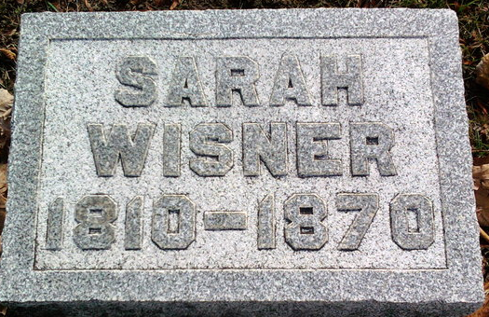
Photo by Thomas Liby

Sarah Plummer from tree Warfield
Birth 1810 Johnstown, Cambria, Pennsylvania, USA
Marriage 1833 Lycoming, Pennsylvania, USA
Residence 1870 Bluffton, Wells, Indiana, USA
Death 7 Sep 1870 Wells, Indiana, USA
Spouse Aaron Wisner (1810-1883)

