Sarah Wisner
October 23, 1833 – January 23, 1910

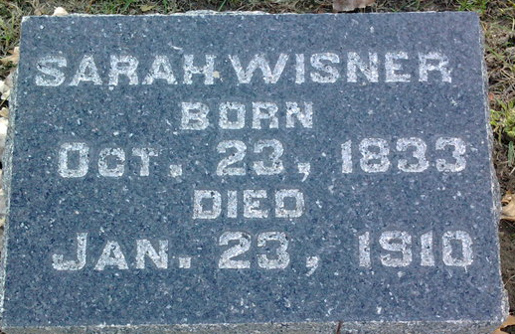
Photo by Thomas Liby

Sarah Wisner
in the Indiana, U.S., Death Certificates, 1899-2017
Name Sarah Wisner
Gender Female
Race White
Marital Status Single
Age 77
Birth Date 23 Oct 1832 (sic)
Birth Place Pennsylvania
Death Date 23 Jan 1910
Death Place Lancaster, Wells, Indiana, USA
Death Registration Date 1910
Father Wm Wisner
Mother Mary Plummer
Informant Silas Wisner; Bluffton, Indiana
Burial January 25, 1910; Elm Grove Cemetery

