Richard P. Wisner
August 12, 1834 – November 18, 1905

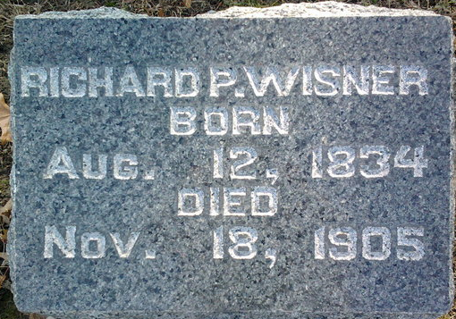
Photo by Thomas Liby

Richard Wesner
in the Indiana, U.S., Death Certificates, 1899-2017

Name Richard Wisner
Gender Male
Race White
Marital Status Single
Age 71
Birth Date 12 Aug 1834
Birth Place Ohio
Death Date 18 Nov 1905
Death Place Lancaster, Wells, Indiana, USA
Death Registration Date 1905
Father William Wisner
Mother Mary Plumber
Informant Family
Burial November 20, 1905; Elm Grove Cemetery

