Nancy Ann Wisner
December 8, 1850 – September 16, 1914

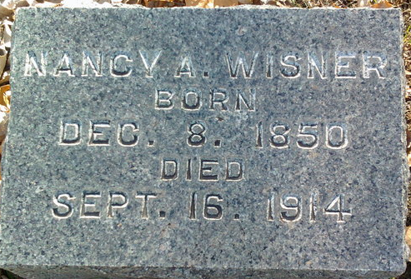
Photo by Thomas Liby

Nancy Ann Wisner
in the Indiana, U.S., Death Certificates, 1899-2017
Name Nancy Ann Wisner
Gender Female
Race White
Marital Status Single
Age 63
Birth Date 8 Dec 1850
Birth Place Indiana
Death Date 16 Sep 1914
Death Place Lancaster, Wells, Indiana, USA
Death Registration Date 1910-1919
Father William Wisner
Mother Mary Plumer
Informant Mary Mock; Poneto, Indiana
Burial September 18, 1914; Elm Grove Cemetery

