Mary (Plummer) Wisner
April 25, 1810 – September 3, 1863

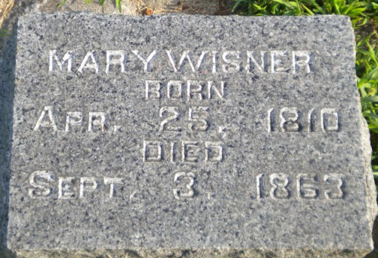
Photo by PLGS

Mary Plummer from tree Warfield
Birth 25 Apr 1810 Johnstown, Cambria, Pennsylvania, USA
Marriage 1832 Lycoming, Pennsylvania, USA
Residence 1860 Wells, Indiana, USA
Death 3 Sep 1863 Wells, Indiana, USA
Spouse William Wisner (1808-1888)

