Mary Jane (Peppard) Wisner
April 26, 1837 – January 23, 1912

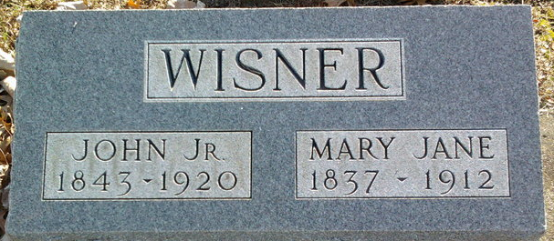
Photo by Thomas Liby

Mary Jane Wisner
in the Indiana, U.S., Death Certificates, 1899-2017
Name Mary Jane Wisner
Gender Female
Race White
Marital Status Married
Age 74
Birth Date 26 Apr 1837
Birth Place Ohio
Death Date 23 Jan 1912
Death Place Fort Wayne, Allen, Indiana, USA
Death Registration Date 1912
Father David Peppard
Mother Margaret Morison
Spouse John Wisner
Informant John Wisner; Fort Wayne, Indiana
Burial January 25, 1912; Bluffton, Indiana

