Mary E. (Rockwell) Wisner
June 16, 1884 – November 26, 1947

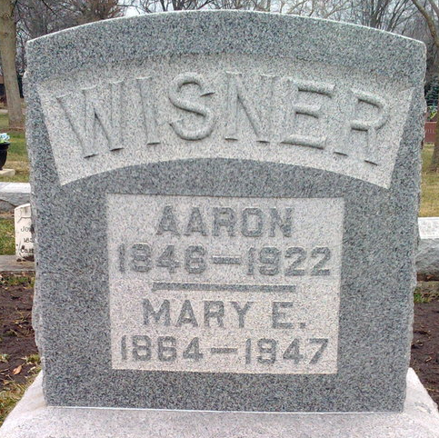
Photo by Thomas Liby

Mary Wisner
in the Indiana, U.S., Death Certificates, 1899-2017
Name Mary Wisner
[Mary Rockwell]
Gender Female
Race White
Marital Status Widow
Age 81
Birth Date 16 Jun 1866(sic)
Birth Place Melina Ohio
Death Date 26 Nov 1947
Death Place Rural, Kosciusko, Indiana, USA
Death Registration Date 1947
Father James Rockwell
Mother Mary Allen
Spouse Aaron Wisner; deceased
Informant Rev. Matthew Worthman; Bluffton, Indiana
Burial November 29, 1947; Elm Grove Cemetery; Bluffton, Indiana

