Marion Wisner
May 24, 1869 – September 2, 1880

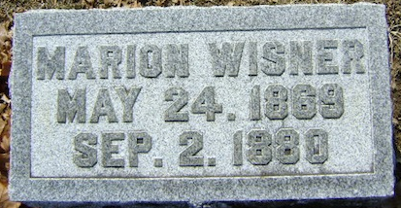
Photo by Bruce Sonner

Marion Wisner from tree Phillips - Weber Family Tree
Birth 24 May 1869 Wells, Indiana, USA
Residence 1880 Wells, Indiana, USA
Death 2 Sep 1880 Wells, Indiana, USA
Father John Wisner (1834-1917)
Mother Sophia Kunkle (1840-1879)

