Margaret A. (Karns) Wisner
1855 – May 25, 1895

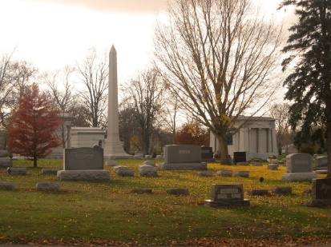
Photo by Tombstoner & Family

Mrs. H. L. Wisner, the wife of Deputy Clerk Wisner of Bluffton, died at her home last Friday. The funeral took place from the Baptist Church there on Sunday.
Democratic Press; Adams Countyy, Indiana
Thursday, May 30, 1895
**
Indiana, U.S., Marriage Index, 1800-1941
Name Horace L. Wisner
Marriage Date 7 Feb 1877
Marriage Place Wells, Indiana, USA
Spouse Name Maggie A. Karns
**
Kentucky, U.S., Marriage Records, 1852-1914
Name Horace L Wisner
Marriage Date 25 Dec 1901
Marriage Place Kentucky, USA
Marriage Registration Date 1901
Marriage Registration Place Jefferson, Kentucky, USA
Spouse Name Alethea B Sloane
**
Margaret A "Maggie" Karns from tree Belden Jr Family Tree
Birth 1855 Indiana, USA
Marriage 7 Feb 1877 Wells, Indiana, USA
Residence 1880 Bluffton, Wells, Indiana, USA
Death 25 May 1895 Bluffton, Wells, Indiana, USA
Father Sanford Ramie Karns (1812-1881)
Mother Margaret McBride (1819-1904)
Spouse Horace Leland Wisner (1853-1919)

