John Wisner Sr.
February 2, 1834 – May 22, 1917

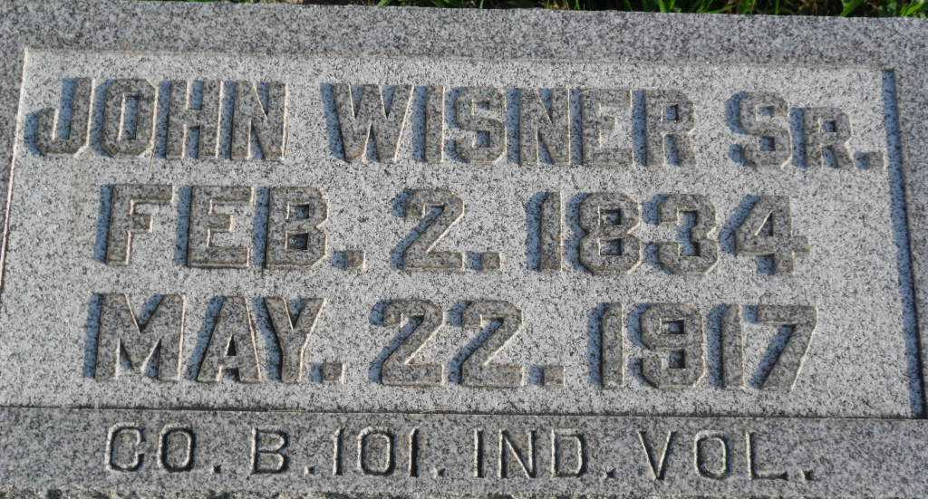
Photo by PLGS

John Wisner
in the Indiana, U.S., Death Certificates, 1899-2017
Name John Wisner
Gender Male
Race White
Marital Status Widower
Age 83
Birth Date 7 Feb 1834(sic)
Birth Place Pennsylvania
Death Date 22 May 1917
Death Place Bluffton, Wells, Indiana, USA
Death Registration Date 1917
Father Aaron Wisner
Mother Sarah Plummer
Spouse Sophia Kunkle
Informant Frank Wisner; Bluffton, Indiana
Burial May 24, 1917; Elm Grove Cemetery

